view->sql server object explorer
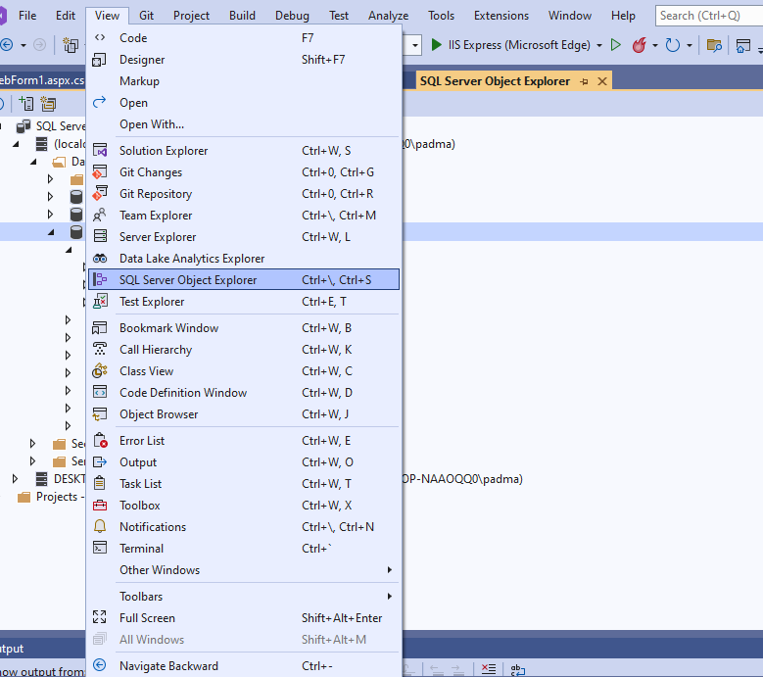

databases-> add new databases
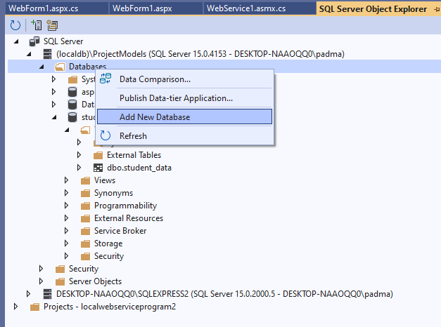
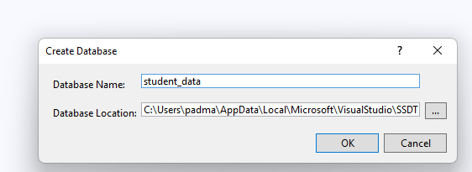

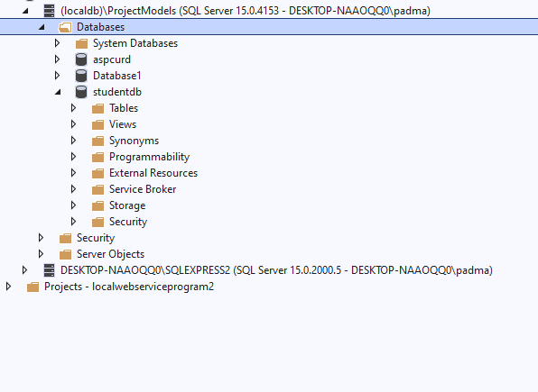
Right on tables folder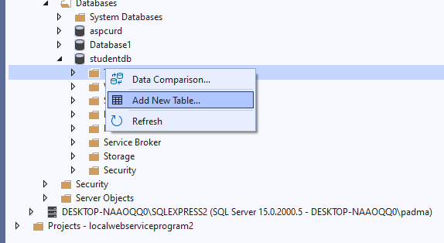
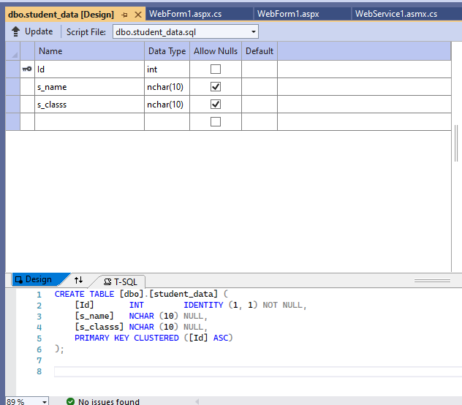

START ->VISUAL STUDIO-> CREATE ASP.NET ->EMPTY WEB APPLICATION->
GO TO VIEW-> SERVER EXPLORER

GO TO SOLUTION EXPLORER->
RIGHT CLICK ON PROJECT NAME-> ADD NEW ITEM->
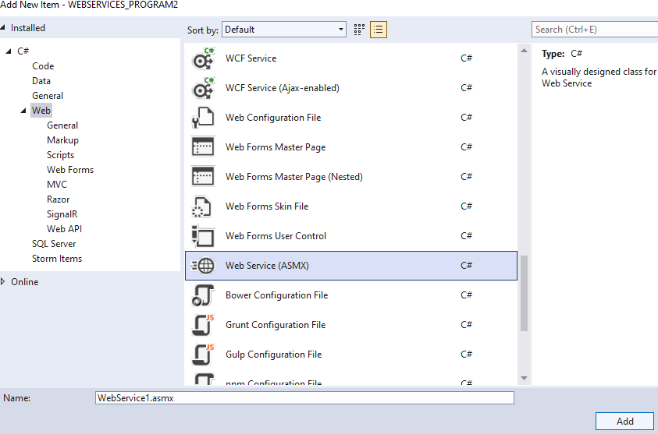
- [WebMethod] attribute
The "[WebMethod]" attribute is a way by which the methods of the service are enabled to be called remotely.
This attribute is written just above the webmethod.
- Description parameter
"Description" is an extra parameter that allows us to describe the webmethod.
Using this we simply describe our methods.
Now once again go to your Service.cs page and add the Description parameter to each and every method and whatever a description shows, that is what your webmethod is going to do.

NOW THE WEBSERVICES1.ASMX FILE WILL OPEN
Carete 2 method inside the webservice1 class
- Public dataset selectdata()
- Public int insertdata()

public class WebService1 : System.Web.Services.WebService
{
SqlConnection con = new SqlConnection(@"Data Source=(localdb)\ProjectModels;Initial Catalog=studentdb;Integrated Security=True;Connect Timeout=30;Encrypt=False;TrustServerCertificate=False;ApplicationIntent=ReadWrite;MultiSubnetFailover=False");

[WebMethod]
public string HelloWorld()
{
return "Hello World";
}

[WebMethod]
public DataSet SelectData()
{
SqlDataAdapter da = new SqlDataAdapter("select * from student_data ", conn);
System.Data.DataSet ds = new DataSet();
da.Fill(ds);
return ds;
}
[WebMethod]
public int insertData(string name, string classname)
{
con.Open();

SqlCommand cmd = new SqlCommand("insert into student_data values('" + name + "', '" + classname + "')", con);
int res = cmd.ExecuteNonQuery();
return res;
}

}

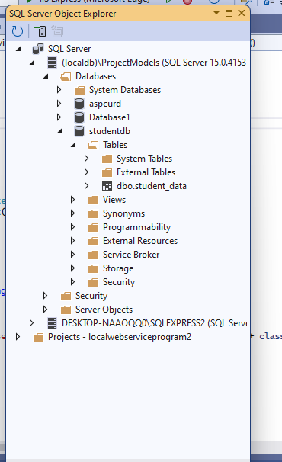
SELECT THE DATABASE-> HERE I HAVE SELECTED student_data->RIGHT CLICK ON DATABASE ->GO TO PROPERTIES->
COPY THE CONNECTION STRING
PASTE IT ON
SqlConnection con = new SqlConnection(@"PASTE THE CONNECTION STRING ");
Add new-> webform1
Design
Add below control
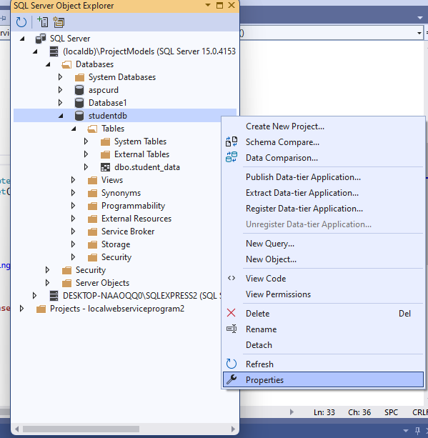

Execute the the webservice1

After that create a service reference -> right click on project-> add -> service references

Create a service references->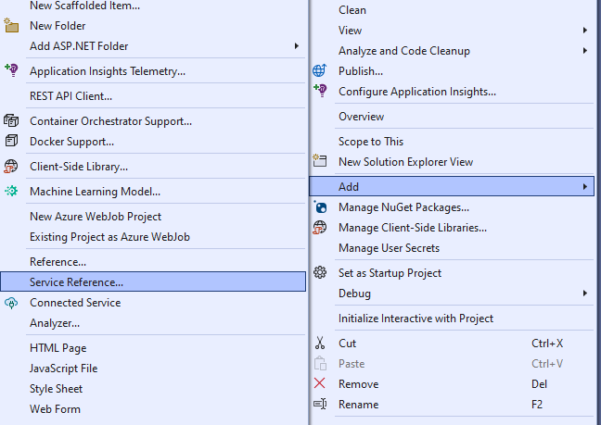
Click on discover -> select the service solution explorer
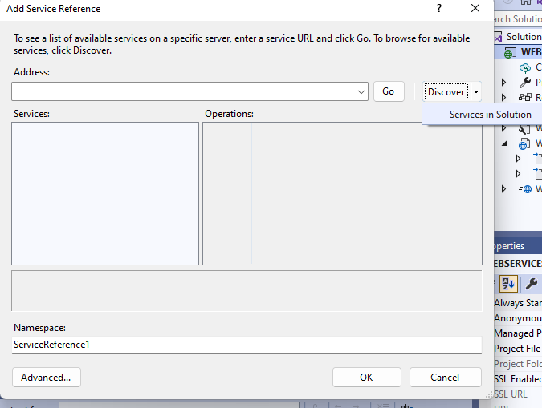
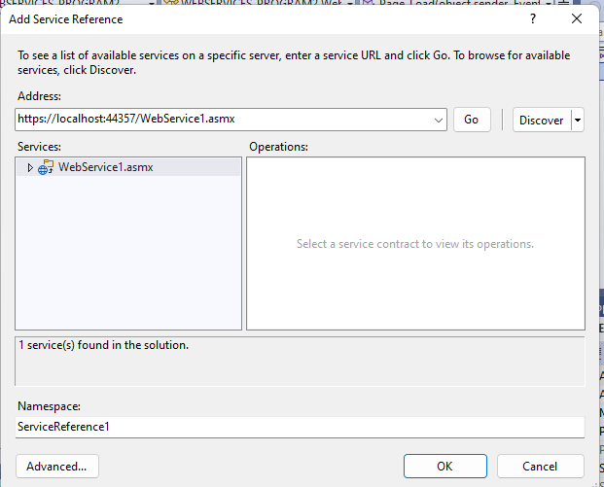
Click on ok
Servicerefernce1 will be added in solution explorer
Right click on project ->Add new-> webform1

Design
Add below control
webform1->right click->set as start page
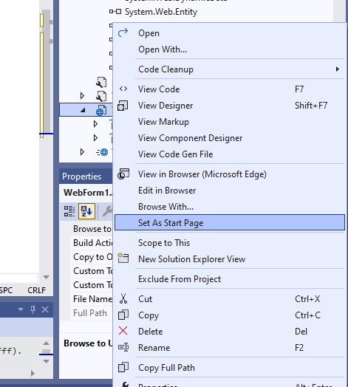
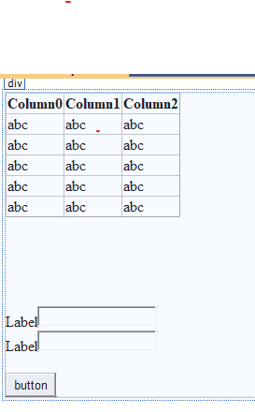
<asp:GridView ID="GridView1" runat="server">
</asp:GridView>
<br />
<br />
<asp:Label ID="Label1" runat="server" Font-Size="X-Large" Text="name "></asp:Label>
<asp:TextBox ID="TextBox1" runat="server"></asp:TextBox>
<br />
<br />
<asp:Label ID="Label2" runat="server" Font-Size="X-Large" Text="class"></asp:Label>
<asp:TextBox ID="TextBox2" runat="server"></asp:TextBox>
<br />
<br />
<asp:Button ID="Button1" runat="server" Text="insert" />

Webform1.aspx.cs

public partial class WebForm1 : System.Web.UI.Page
{
WebService1 ws = new WebService1();

protected void Page_Load(object sender, EventArgs e)
{
if (!this.IsPostBack)
{
this.BindGrid();
}

}
private void BindGrid()
{
DataSet ds = new DataSet();
ds = ws.SelectData();
GridView1.DataSource = ds;
GridView1.DataBind();
}

protected void Button3_Click(object sender, EventArgs e)
{
int res = ws.insertData(TextBox1.Text, TextBox2.Text);
if (res > 0)
{
Response.Write("Inserted");
}
this.BindGrid();

}

}

